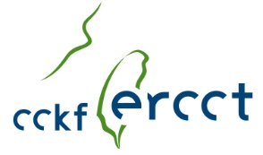
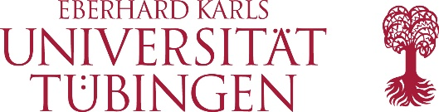

ERCCT Grant
to participate in the 8th CCKF-ERCCT „Young Scholars Workshop“ in Germany, Summer 2020, for the best paper presented to the Taiwan Political Science Association 2019 Annual Conference
The European Research Center on Contemporary Taiwan – A CCK Foundation Overseas Center (CCKF-ERCCT) at the Eberhard Karls University Tübingen, Germany, will hold a workshop for emerging young scholars from 28 June to 4 July, 2020. The CCKF-ERCCT will, by way of a TPSA support letter, invite the author of the most outstanding paper written and presented by a young scholar (PhD or Postdoc level) at the TPSA 2019 Annual Conference to participate in the 8th “Young Scholars Workshop”. This established format provides selected young scholars from Taiwan and Europe with the opportunity to
- present their research to an international audience of peers
- engage in scholarly exchange on theory and methodology
- discuss publication strategies
- get to know Tübingen, the CCKF-ERCCT and Tübingen university
Travel expenses and accommodation will be fully covered by the CCKF-ERCCT. The selected winner should send his/her CV and an outline of his/her research project (5-6 pages) until 31 January, 2020 to:
Stefan Braig, M.A.
ERCCT Managing Director
Mail: stefan.braig@uni-tuebingen.de

